ALLAMA IQBAL OPEN UNIVERSITY, ISLAMABAD

**(Department of Business Administration)**

|  |
| --- |
| **WARNING**   1. **PLAGIARISM OR HIRING OF GHOST WRITER(S) FOR SOLVING THE ASSIGNMENT(S) WILL DEBAR THE STUDENT FROM THE AWARD OF DEGREE/CERTIFICATE IF FOUND AT ANY STAGE.** 2. **SUBMITTING ASSIGNMENT(S) BORROWED OR STOLEN FROM OTHER(S) AS ONE’S OWN WILL BE PENALIZED AS DEFINED IN THE “AIOU PLAGIARISM POLICY”.** |

**Course: Production and Operations Management Code: 9545/8418/5032**

**Level: PGD/ BBA/ BS Semester: Spring, 2025**

**Credit Hours: 03**

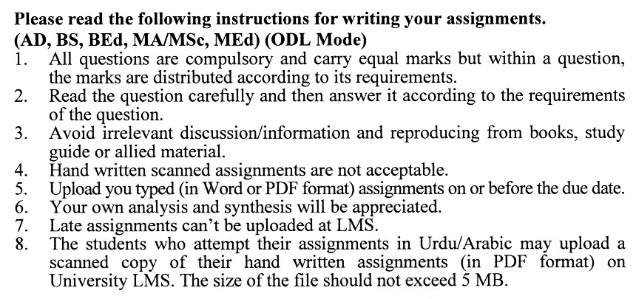

**Total Marks: 100 Pass Marks: 50**

**ASSIGNMENT No. 1**

***Note: Attempt all the questions.***

Q. 1 What are the key differences between production management and operations management, and how do they contribute to overall organizational efficiency? **(20)**

Q. 2 How does capacity planning influence long-term production goals, and what strategies can organizations implement to optimize capacity utilization? **(20)**

Q. 3 What role does supply chain management play in enhancing production processes, and how can firms mitigate risks associated with supply chain disruptions? **(20)**

Q. 4 How can lean manufacturing and Six Sigma methodologies improve operational performance, and what are the challenges in implementing these approaches? **(20)**

Q. 5 What is the significance of quality control in production management, and how do modern technologies (such as AI and IoT) shape quality assurance processes? **(20)**

**ASSIGNMENT No. 2**

**Total Marks: 100 Pass Marks: 50**

This assignment is a research-oriented activity. You are required to obtain information from a business/commercial organization and prepare a report of about 1000 words on the issue allotted to you to be submitted to your teacher for evaluation.

You are required to select one of the following issues according to the last digit of your roll number. For example, if your roll number is P-3427180 then you will select issue # 0 (the last digit): -

**ISSUES:**

1. Quality Control Methods
2. Capacity Planning Environment
3. ABC Inventory Model
4. Probabilistic Time Estimate (PERT)
5. Problems of Production Management
6. Learning Curve Analysis
7. Simulation
8. Forecasting
9. Basic Approaches to Maintenance

9. Total Quality Manager

****