ALLAMA IQBAL OPEN UNIVERSITY, ISLAMABAD

**(Department of Distance, Non-Formal & Continuing Education)**

|  |
| --- |
| **WARNING**   1. **PLAGIARISM OR HIRING OF GHOST WRITER(S) FOR SOLVING THE ASSIGNMENT(S) WILL DEBAR THE STUDENT FROM THE AWARD OF DEGREE/CERTIFICATE IF FOUND AT ANY STAGE.** 2. **SUBMITTING ASSIGNMENT(S) BORROWED OR STOLEN FROM OTHER(S) AS ONE’S OWN WILL BE PENALIZED AS DEFINED IN THE “AIOU PLAGIARISM POLICY”.** |

**Course: Educational Technology (8619) Semester: Spring, 2025**

**Level: B.Ed (1.5 Years)**

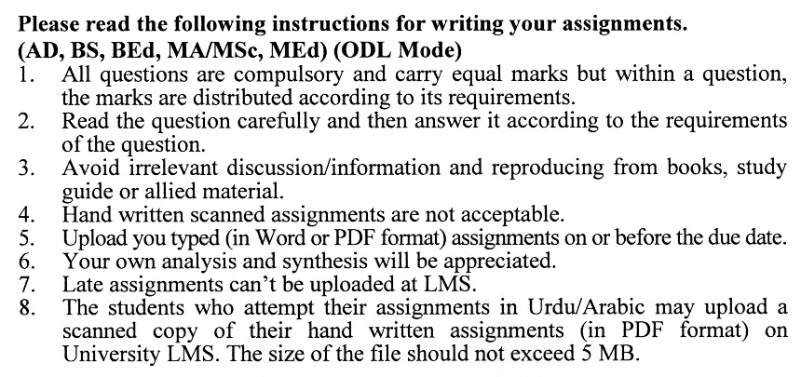

**Total Marks: 100 Pass Marks: 50**

**ASSIGNMENT No. 1**

**(Units: 1­–5)**

**Note: All questions are compulsory and carry equal marks.**

Q. 1 If you have to teach at the primary level, how do you incorporate the basics of educational technology into your teaching? Discuss. **(20)**

Q. 2 Distinguish between salient features of cognitivism and behaviorism. **(20)**

Q. 3 Critically examine the role of the teacher in learning. **(20)**

Q. 4 Discuss the hierarchy of objectives. **(20)**

Q. 5 Critically examine the discussion strategy in the teaching-learning process. **(20)**

**Total Marks: 100 Pass Marks: 40**

**ASSIGNMENT No. 2**

**(Units: 6–9)**

Q. 1 Explain the importance of educational radio and television. Which medium is more effective in Pakistan and why? **(20)**

Q. 2 Evaluate the non-verbal factors in oral communication. Give examples. **(20)**

Q. 3 Discuss the important models of teaching. **(20)**

Q. 4 Critically examine your role as a teacher in using the audio-visual materials to make the reaching-learning process effective at efficient. **(20)**

Q. 5 How interactive video can be used in distance education? **(20)**

