**ALLAMA IQBAL OPEN UNIVERSITY, ISLAMABAD**

***(Department of Educational Planning, Policy Studies and Leadership)***

|  |
| --- |
| **WARNING**   1. **PLAGIARISM OR HIRING OF GHOST WRITER(S) FOR SOLVING THE ASSIGNMENT(S) WILL DEBAR THE STUDENT FROM THE AWARD OF DEGREE/CERTIFICATE IF FOUND AT ANY STAGE.** 2. **SUBMITTING ASSIGNMENT(S) BORROWED OR STOLEN FROM OTHER(S) AS ONE’S OWN WILL BE PENALIZED AS DEFINED IN THE “AIOU PLAGIARISM POLICY”.** |

**Course: Educational Human Resource Management (8688)**

**Level: B.Ed (4 Years) Semester: Spring, 2025**

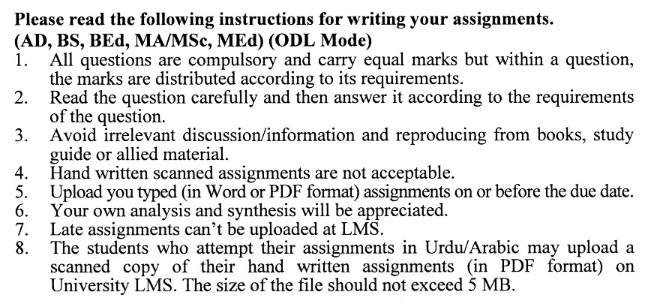

**Total Marks: 100 Pass Marks: 50**

**ASSIGNMENT No. 1**

**(Units: 1–4)**

Q. 1 What are the functions of the key roles in the hierarchy of the school education department in Pakistan, from the Provincial Minister of Education to the Support Staff? **(20)**

Q. 2 What are the key steps involved in conducting a needs analysis, and how do these steps contribute to identifying and addressing training gaps in an organization? **(20)**

Q. 3 What are the primary goals of human resource forecasting, and how do different forecasting techniques, such as ratio-trend analysis and regression analysis, help organizations estimate future manpower needs? **(20)**

Q. 4 What are the key stages in the recruitment process within educational institutions, and how can recruitment practices be aligned with the institution’s goals, diversity initiatives, and technological advancements? **(20)**

Q. 5 What are the key selection criteria employers should consider when evaluating potential candidates for a job, and how do these criteria contribute to identifying the best-suited candidate for the role? **(20)**

**Total Marks: 100 Pass Marks: 50**

**ASSIGNMENT No. 2**

**(Units: 5–9)**

Q. 1 What are the key areas of significance for Human Resource Development (HRD), and how does it contribute to the growth and success of an organization? **(20)**

Q. 2 How does performance management contribute to the overall success of Educational Human Resource Management (EHRM), and what are its key components and benefits in an organization? **(20)**

Q. 3 What are some of the challenges of Human Resource Management in education, and how do they impact the achievement of educational objectives? **(20)**

Q. 4 What are the different components of direct compensation, and how do they contribute to an employee's overall remuneration package? **(20)**

Q. 5 What are the key steps in Human Resource Planning (HRP), and how does HRIS support this process? Also, discuss the challenges HR managers face in HRP. **(20)**

****