**ALLAMA IQBAL OPEN UNIVERSITY, ISLAMABAD**

**(Department of History)**

**WARNING**

1. **PLAGIARISM OR HIRING OF GHOST WRITER(S) FOR SOLVING THE ASSIGNMENT(S) WILL DEBAR THE STUDENT FROM AWARD OF DEGREE/CERTIFICATE, IF FOUND AT ANY STAGE.**
2. **SUBMITTING ASSIGNMENT(S) BORROWED OR STOLEN FROM OTHER(S) AS ONE’S OWN WILL BE PENALIZED AS DEFINED IN “AIOU PLAGIARISM POLICY”.**

**Course: History of Umayyads (9144) Semester: Spring, 2025**

**Level: BS History**

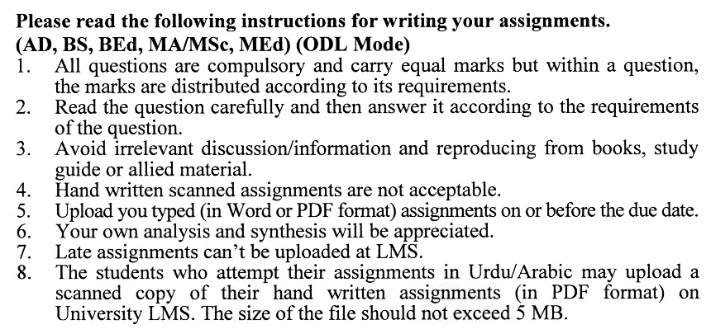

**Total Marks: 100 Pass Marks: 50**

**ASSIGNMENT No. 1**

**(Units: 1–4)**

Q. 1 Evaluate the diplomatic and military policies of Caliph Muawiya I in consolidating and expanding the Umayyad Caliphate. **(20)**

Q. 2 Examine the causes and consequences of the Battle of Karbala (680 CE) during the reign of Yazid I. **(20)**

Q. 3 What were the significant challenges faced by Muawiya II during his reign, and how did they contribute to the eventual rise of Marwan I? **(20)**

Q. 4 Discuss the role of Marwan I in re-establishing the authority of the Umayyad dynasty after the crises following Yazid I and Muawiya II.  **(20)**

Q. 5 Evaluate the impact of Yazid I’s military campaigns, particularly the Battle of Harra and the siege of Mecca, on the unity of the Muslim Ummah. What were the long-term implications of these events for the legitimacy of the Umayyad dynasty? **(20)**

**Total Marks: 100 Pass Marks: 50**

**ASSIGNMENT No. 2**

**(Units: 5–8)**

Q. 1 Analyse the administrative and monetary reforms of Abdul Malik ibn Marwan. How did these reforms consolidate Umayyad authority and enhance the caliphate's economic stability? **(20)**

Q. 2 **Analyse the military campaigns during the reign of Al-Walid ibn Abdul Malik, particularly the expansion into North Africa, Spain, and Central Asia. What role did these conquests play in shaping the caliphate’s global reach? (20)**

Q. 3 Abdul Malik Ibn Marwan is often regarded as the true founder of the Umayyad dynasty's enduring legacy. Critically assess this claim by evaluating his role in restoring the dynasty's authority. **(20)**

Q. 4 Discuss Suleman ibn Abdul Malik’s approach to succession and governance. How did his policies and decisions reflect his priorities for the caliphate's future? **(20)**

Q. 5 Examine the reforms introduced by Umar ibn Abdul Aziz to address issues of justice, taxation, and the treatment of non-Muslims (dhimmis). How did these policies distinguish his rule from other Umayyad caliphs? **(20)**

