**ALLAMA IQBAL OPEN UNIVERSITY, ISLAMABAD**

**(Department of Mass Communication)**

## Course: Research Methods in Mass Communication – II (9278)

## Level: BS Semester: Spring, 2025

## Total Marks: 100 Pass Marks: 50

**Credit Hours: 03**

### **INSTRUCTIONS:**

1. Assignments 1 and 2 cover units 1–4 and 5–9 respectively.

2. Each assignment carries 100 marks.

3. Write the assignments in your own words.

Since the nature of assignment questions requires you to be more analytical, supplement material from the study guides with information from other suggested readings could be incorporated into it. Some of the questions require to include examples from Pakistani perspectives/settings. So do not simply rehash material from the study guide verbatim but rely on synthesizing materials from different units of the study guide in your language.

# **LIST OF CONTENTS:**

This package comprises the following material:

1. Study Guide (Available online)

2. Assignments 1 and 2

Best of Luck

##### *(****Dr. Asad Munir****)*

##### *Course Coordinator*

ALLAMA IQBAL OPEN UNIVERSITY, ISLAMABAD

**(Department of Mass Communication)**

|  |
| --- |
| **WARNING**   1. **PLAGIARISM OR HIRING OF GHOST WRITER(S) FOR SOLVING THE ASSIGNMENT(S) WILL DEBAR THE STUDENT FROM THE AWARD OF DEGREE/CERTIFICATE IF FOUND AT ANY STAGE.** 2. **SUBMITTING ASSIGNMENT(S) BORROWED OR STOLEN FROM OTHER(S) AS ONE’S OWN WILL BE PENALIZED AS DEFINED IN THE “AIOU PLAGIARISM POLICY”.** |

**Course: Research Methods in Mass Communication – II (9278)**

**Level: BS Semester: Spring, 2025**

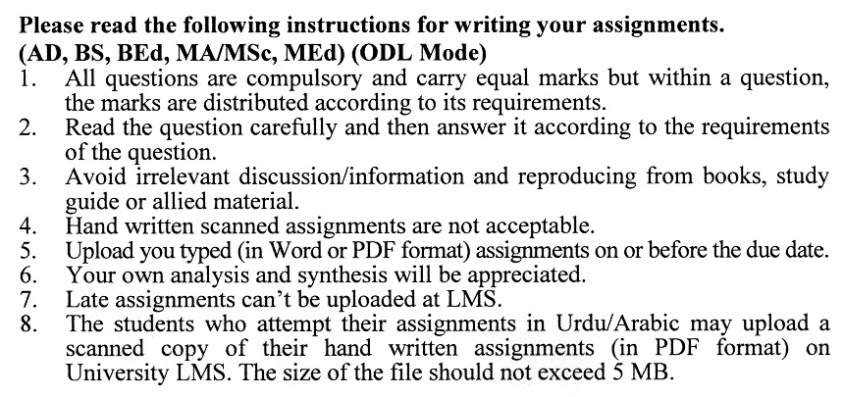

## Total Marks: 100 Pass Marks: 50

**ASSIGNMENT No. 1**

**(Units: 1–4)**

Q. 1 Why do we measure the central tendency of a data set? Discuss its process as well. HoeHow **(20)**

Q. 2 Explain Research Questions and alternate and Null Hypotheses with examples. **(20)**

Q. 3 Discuss different statistical procedures to analyze mean differences. **(20)**

Q. 4 What are the rules for writing a research report/ thesis? Discuss. **(20)**

Q. 5 Discuss salient qualitative research methods used in mass media research. **(20)**

## Total Marks: 100 Pass Marks: 50

**ASSIGNMENT No. 2**

**(Units: 5–9)**

Q. 1 What are Cognitive, Affective and Conative Dimensions of Copy Testing? **(20)**

Q. 2 Explain different types of Public Relations Research. **(20)**

Q. 3 How can we measure the antisocial and pro-social effects of media? Discuss. **(20)**

Q. 4 Elaborate general ethical principles of research writing. **(20)**

Q. 5 Write a detailed note on computer applications in research. **(20)**

