**ALLAMA IQBAL OPEN UNIVERSITY, ISLAMABAD**

**(Department of Business Administration)**

**WARNING**

1. **PLAGIARISM OR HIRING OF GHOST WRITER(S) FOR SOLVING THE ASSIGNMENT(S) WILL DEBAR THE STUDENT FROM THE AWARD OF DEGREE/CERTIFICATE IF FOUND AT ANY STAGE.**
2. **SUBMITTING ASSIGNMENTS BORROWED OR STOLEN FROM OTHER(S) AS ONE’S OWN WILL BE PENALIZED AS DEFINED IN THE“AIOU PLAGIARISM POLICY”.**

**Course: Marketing for Entrepreneurship (9554) Semester: Spring, 2025**

**Level: PGD (ENTREPRENEURSHIP)**

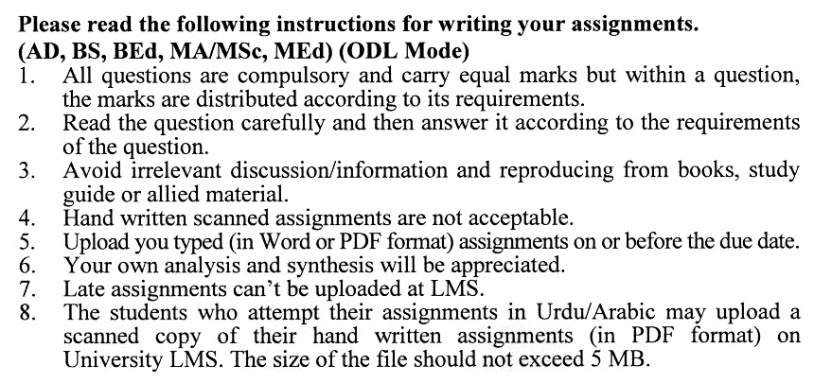

**Total Marks: 100 Pass Marks: 50**

## ASSIGNMENT No. 1

Q. 1 What is Entrepreneurial marketing? Who employs it? Also discuss entrepreneurial marketing tips. (20)

Q. 2 How is an entrepreneurial marketing plan developed and implemented? Also, describe the role of entrepreneurs in entrepreneurial marketing. (20)

Q.3 Discuss with logic the role of research in entrepreneurial marketing., and ensure the entrepreneurial success. (20)

Q.4 Discuss the process of new product development and discuss the adoption and diffusion with illustration. (20)

Q.5 Write a short note on the following: (20)

1) Market segmentation

2) External environment

3) Supply Chain Management

4) Business Plan and Marketing Plan

**Total Marks: 100 Pass Marks: 50**

**ASSIGNMENT No. 2**

This assignment is a research-oriented activity. You are required to obtain information from a business/commercial organization and prepare a report of about 1000 words on the issue allotted to you to be submitted to your teacher for evaluation.

You are required to select one of the following issues according to the last digit of your roll number. For example, if your roll number is P-3427180 then you will select issue # 0 (the last digit): -

List of Topics

1. Market Segmentation
2. Ethics in Consumer Research
3. Evaluating Marketing Opportunities
4. The Entrepreneurial branding process
5. Developing new product and service
6. Promotion mix
7. Supply chain management
8. Product life cycle
9. Marketing process for new ventures
10. Types and characteristics of product and services

The report should follow the following format:

1. Title page
2. Acknowledgements
3. An abstract (one page summary of the paper)
4. Table of contents
5. Introduction to the issue (brief history & significance of issue assigned)
6. Practical study of the organization (with respect to the issue)
7. Data collection methods
8. SWOT analysis (strengths, weaknesses, opportunities & threats) relevant to the issue assigned
9. Conclusion (one page brief covering important aspects of your report)
10. Recommendations (specific recommendations relevant to the issue assigned)
11. References (as per APA format)
12. Annexes (if any)
13. GUIDELINES FOR ASSIGNMENT # 2:

* 1.5 line spacing
* Use headers and subheads throughout all sections
* Organization of ideas
* Writing skills (spelling, grammar, punctuation)
* Professionalism (readability and general appearance)
* Do more than repeat the text
* Express a point of view and defend it.

**PRESENTATION:**

Presentations provide you the opportunity to express your communication skills, knowledge and understanding of concepts learned during practical study assigned in assignment No. 2.

You should use transparencies and any other material for effective presentation. The transparencies are not the presentation, but only a tool; the presentation is the combination of the transparencies and your speech. Workshop presentation transparencies should only be in typed format.

The transparencies should follow the following format:

1. Title page
2. An abstract (one page summary of the paper)
3. Introduction to the issue (brief history & significance of issue assigned)
4. Practical study of the organization (with respect to the issue)
5. Data collection methods
6. SWOT analysis (strengths, weaknesses, opportunities & threats) relevant to the issue assigned
7. Conclusion (one page brief covering important aspects of your report)
8. Recommendations (specific recommendations relevant to the issue assigned)