**ALLAMA IQBAL OPEN UNIVERSITY, ISLAMABAD**

**(Department of Mass Communication)**

## Course: Media Ethics & Laws – II (9282) Semester: Spring, 2025

## Level: BS Total Marks: 100

**Credit Hours: 03 Pass Marks: 50**

### **INSTRUCTIONS:**

1. Assignments 1 and 2 cover units 1–4 and 5–9 respectively.

2. Each assignment carries 100 marks.

3. Write the assignments in your own words.

Since the nature of assignment questions requires you to be more analytical, therefore, supplement material from the study guides with information from other suggested readings could be incorporated into it. Some of the questions require to include examples from Pakistani perspectives/setting. So do not simply rehash material from the study guide verbatim but rely on synthesizing materials from different units of the study guide in your language.

# **LIST OF CONTENTS:**

This package comprises the following material:

1. Study Guide (Available online)

2. Assignments 1 and 2

Best of Luck

##### *(****Dr. Asad Munir****)*

##### *Course Coordinator*

ALLAMA IQBAL OPEN UNIVERSITY, ISLAMABAD

**(Department of Mass Communication)**

|  |
| --- |
| **WARNING**   1. **PLAGIARISM OR HIRING OF GHOST WRITER(S) FOR SOLVING THE ASSIGNMENT(S) WILL DEBAR THE STUDENT FROM THE AWARD OF DEGREE/CERTIFICATE IF FOUND AT ANY STAGE.** 2. **SUBMITTING ASSIGNMENT(S) BORROWED OR STOLEN FROM OTHER(S) AS ONE’S OWN WILL BE PENALIZED AS DEFINED IN THE “AIOU PLAGIARISM POLICY”.** |

**Course: Media Ethics & Laws – II (9282) Semester: Spring, 2025**

**Level: BS**

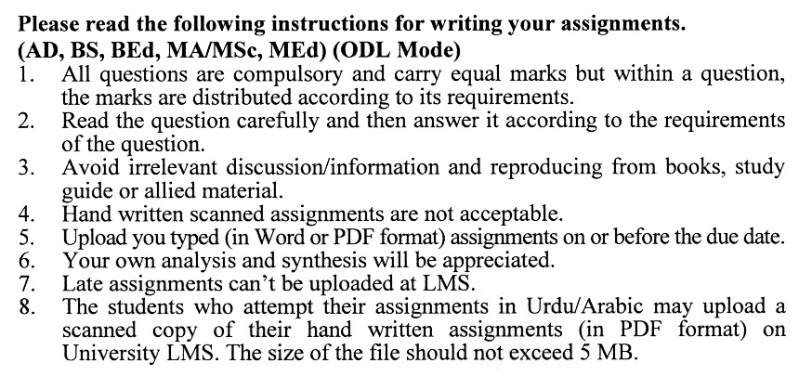

## Total Marks: 100 Pass Marks: 50

**ASSIGNMENT No. 1**

**(Units: 1–4)**

Q. 1 Elaborate on the brief history of the legal framework for media in Pakistan. **(20)**

Q. 2 What are landing rights? Describe the procedure to acquire landing rights. **(20)**

Q. 3 Explain the PEMRA legislation 2002 in detail. **(20)**

Q. 4 Write a note on the procedure to acquire a license for a radio station in Pakistan. **(20)**

Q. 5 Elaborate different key terms used in PEMRA Rules. **(20)**

## Total Marks: 100 Pass Marks: 50

**ASSIGNMENT No. 2**

**(Units: 5–9)**

Q. 1 Discuss print media ethics in reporting news stories, writing editorials and other pieces of journalistic writing. **(20)**

Q. 2 How can a code of ethics be practised in news and current affairs programs? Discuss. **(20)**

Q. 3 What is public relations? Write down the ethical issues of public relations. **(20)**

Q. 4 Critically discuss unethical practices on Pakistani news channels with examples. **(20)**

Q. 5 What is freedom of speech? Also, relate it with the concept of social responsibility. **(20)**

