**ALLAMA IQBAL OPEN UNIVERSITY, ISLAMABAD**

***(Department of Economics)***

**WARNING**

1. **PLAGIARISM OR HIRING OF GHOST WRITER(S) FOR SOLVING THE ASSIGNMENT(S) WILL DEBAR THE STUDENT FROM THE AWARD OF DEGREE/CERTIFICATE IF FOUND AT ANY STAGE.**
2. **SUBMITTING ASSIGNMENT(S) BORROWED OR STOLEN FROM OTHER(S) AS ONE’S OWN WILL BE PENALIZED AS DEFINED IN THE “AIOU PLAGIARISM POLICY”.**

## **Course: Principles of Macroeconomics (9302) Semester: Spring, 2025**

## **Level: Level: BS Economics Credit Hours: 03**

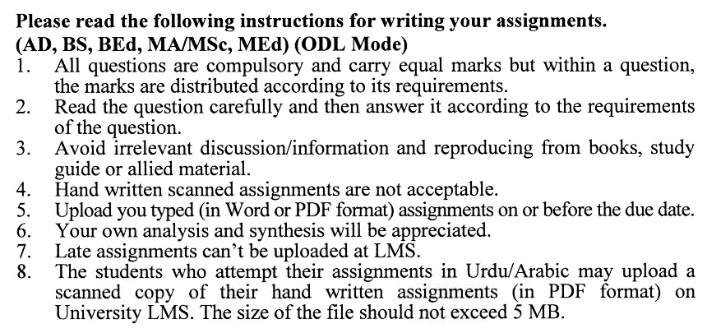

**Total Marks:100 Pass Marks:50**

**ASSIGNMENT NO. 1**

**(Unit: 1-5)**

Q.1 What is Macroeconomics? Also, discuss the evolution of Macroeconomics (20)

Q.2 Discuss in detail the circular flow of national income. (20)

Q.3 Analyze with the help of diagrams the equilibrium in the Labor Market. (20)

Q.4 Explain the basic tools of Finance in detail. (20)

Q.5 Describe the concept of Classical theory of Inflation. (20)

**Total Marks:100 Pass Marks:50**

**ASSIGNMENT NO. 2**

**(Unit: 6-9)**

Q.1 Explain in detail the basic concept of an Open Economy. (20)

Q.2 Discuss the three important factors responsible for economic fluctuations. (20)

Q.3 Explain the role of Monetary Policy in stabilizing the Economy. (20)

Q.4 Explain in concept of Phillip’s Curve in detail. (20)

Q.5 Analyze the theory of efficiency wages. (20)

**ALLAMA IQBAL OPEN UNIVERSITY**

(**Department of Economics**)

|  |
| --- |
| Warning  1. Plagiarism or hiring of ghost writer(s) for solving the assignment(s) will debar the student  from award of degree/certificate, if found at any stage.  2. Submitting assignments borrowed or stolen from other(s) as one’s own will be penalized  as defined in “AIOU plagiarism policy”. |

**Course: Principles of Microeconomics (9301) Semester: Autumn, 2024**

**Level: BS Economics Credit Hours:03**

**Please read the following instructions for writing your assignments.**

1. All questions are compulsory and carry equal marks but within a question, the marks are distributed according to its requirements.
2. Read the question carefully and then answer it according to the requirements of the question.
3. Handwritten scanned assignments are not acceptable.
4. Upload your typed (in Word or PDF format) assignment on or before the due date.
5. Late assignments can’t be uploaded at LMS.
6. Your own analysis and synthesis will be appreciated.
7. Avoid irrelevant discussion /information and reproducing from books, study guide or allied material.

**Total Marks:100 Pass Marks:50**

**ASSIGNMENT NO. 1**

**(Unit: 1-5)**

Q.No.1 Discuss how individuals and firms use the principle of opportunity cost to make choices when confronted with scarcity. (20)

Q.No.2 What is price elasticity of demand? Explain the concept using a graph. (20)

Q.No.3 Explain the Law of Equi-Marginal Utility and its significance in achieving consumer equilibrium. (20)

Q.No.4 Define Marginal Utility and its role in understanding consumer satisfaction. (20)

Q.No.5 Describe how the concept of Indifference Curves can be used to illustrate consumer preferences and the notion of consumer equilibrium. (20)

**ASSIGNMENT NO. 2**

**(Unit: 6-9)**

**Total Marks: 100 Passing Marks: 50**

Q.No.1 Explain the laws of returns to scale and how they affect a firm's production decisions as it grows. (20)

Q.No.2 Analyze the long-run theory of cost in relation to economies and diseconomies of scale, using graphical representation for clarification. (20)

Q.No.3 Discuss the profit maximization strategies that firms adopt in the short run and long run under conditions of perfect competition. (20)

Q.No.4 Compare the efficiency implications of a monopolistic market structure with those of perfect competition. (20)

Q.No.5 Explain the strategic behaviors that firms may adopt in oligopolistic markets, including the use of game theory to predict the actions of competitors. (20)