**ALLAMA IQBAL OPEN UNIVERSITY, ISLAMABAD**

**(Department of Mass Communication)**

## Course: Public Relations (9263) Semester: Spring, 2025

## Level: BS Total Marks: 100

**Credit Hours: 03 Pass Marks: 50**

### **INSTRUCTIONS:**

1. Assignments 1 and 2 cover units 1–4 and 5–9 respectively.

2. Each assignment carries 100 marks.

3. Write the assignments in your own words.

1. Since the nature of assignment questions requires you to be more analytical, therefore, supplement material from the study guides with information from other suggested readings could be incorporated into it. Some of the questions require including examples from a Pakistani perspective/setting. So do not simply rehash material from the study guide verbatim but rely on synthesizing materials from different units of the study guide in your language.

Best of Luck.

##### *(****Dr. Asad Munir****)*

##### *Course Coordinator*

ALLAMA IQBAL OPEN UNIVERSITY, ISLAMABAD

**(Department of Mass Communication)**

|  |
| --- |
| **WARNING**   1. **PLAGIARISM OR HIRING OF GHOST WRITER(S) FOR SOLVING THE ASSIGNMENT(S) WILL DEBAR THE STUDENT FROM THE AWARD OF DEGREE/CERTIFICATE IF FOUND AT ANY STAGE.** 2. **SUBMITTING ASSIGNMENT(S) BORROWED OR STOLEN FROM OTHER(S) AS ONE’S OWN WILL BE PENALIZED AS DEFINED IN THE “AIOU PLAGIARISM POLICY”.** |

**Course: Public Relations (9263) Semester: Spring, 2025**

**Level: BS**

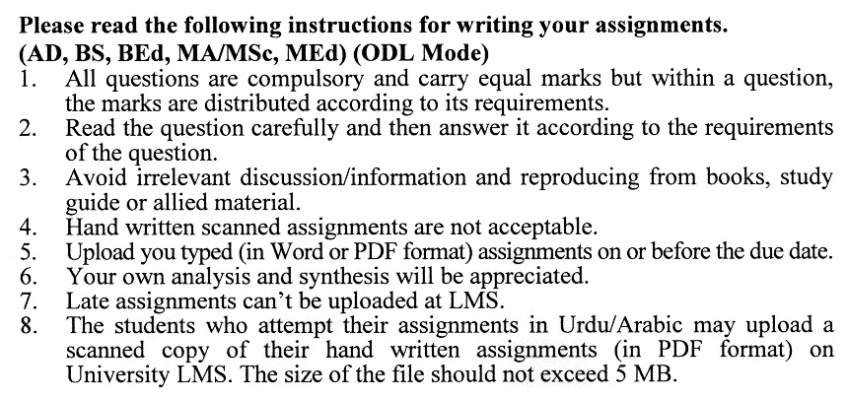

**Total Marks: 100 Pass Marks: 50**

**ASSIGNMENT No. 1**

**(Units: 1–4)**

Q. 1 In the light of different definitions, explain the concept of public relations and describe its functions in general. **(20)**

Q. 2 Describe the duties and responsibilities of a PRO. Also, discuss the tools a PRO uses. **(20)**

Q. 3 Differentiate between government and non-government PR organizations. Explain the different job roles they need to perform. **(20)**

Q. 4 Give a brief history of Public Relations as an industry in Pakistan. **(20)**

Q. 5 Write a detailed analysis of your own on public relations practices in politics. Use appropriate examples from Pakistani settings. **(20)**

**Total Marks: 100 Pass Marks: 50**

**ASSIGNMENT No. 2**

**(Units: 5–9)**

Q. 1 What ethical considerations should be kept in mind during public relations activities? Discuss with examples. **(20)**

Q. 2 Explain the advantages of planning strategies for PR campaigns. What is the difference between publicity and advertising? Explain. **(20)**

Q. 3 What is persuasion? Explain the functions and importance of persuasion techniques in PR work.

**(20)**

Q. 4 Elaborate Press briefing, Press Conference and Press Notes with examples. **(20)**

Q. 5 What is the significance of allied material for publicity and persuasion? Describe different types of allied material. **(20)**

