**ALLAMA IQBAL OPEN UNIVERSITY, ISLAMABAD**

**(Department of Mass Communication)**

## Course: Language Skills and Communicative Abilities (9266) Semester: Spring, 2025

## Level: BS Total Marks: 100

Credit Hours: 03 Pass Marks: 50

### **INSTRUCTIONS:**

1. Assignments 1 and 2 cover units 1–4 and 5–9 respectively.

2. Each assignment carries 100 marks.

3. Write the assignments in your own words.

1. Since the nature of assignment questions requires you to be more analytical, therefore, supplement material from the study guides with information from other suggested readings could be incorporated into it. Some of the questions require including examples from a Pakistani perspective/setting. So do not simply rehash material from the study guide verbatim but rely on synthesizing materials from different units of the study guide in your language.

Best of Luck.

##### *(****Dr. Asad Munir****)*

##### *Course Coordinator*

ALLAMA IQBAL OPEN UNIVERSITY, ISLAMABAD

**(Department of Mass Communication)**

|  |
| --- |
| **WARNING**   1. **PLAGIARISM OR HIRING OF GHOST WRITER(S) FOR SOLVING THE ASSIGNMENT(S) WILL DEBAR THE STUDENT FROM THE AWARD OF DEGREE/CERTIFICATE IF FOUND AT ANY STAGE.** 2. **SUBMITTING ASSIGNMENT(S) BORROWED OR STOLEN FROM OTHER(S) AS ONE’S OWN WILL BE PENALIZED AS DEFINED IN THE “AIOU PLAGIARISM POLICY”.** |

**Course: Language Skills and Communicative Abilities (9266)**

**Level: BS Semester: Spring, 2025**

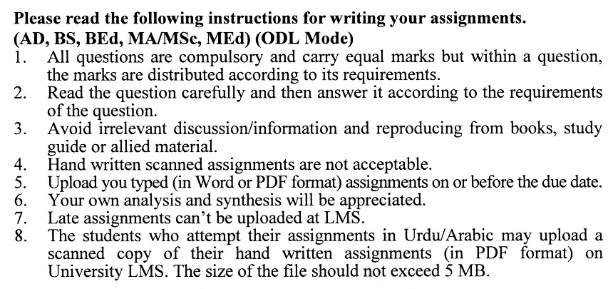

**Total Marks: 100 Pass Marks: 50**

**ASSIGNMENT No. 1**

**(Units: 1–4)**

Q. 1 Define nouns and write down their types with suitable examples. **(20)**

Q. 2 What are different Speech styles? Also, highlight the use of linguistic communication. **(20)**

Q. 3 What is Sentence? Discuss its different clauses in detail. **(20)**

Q. 4 Discuss different mechanics of English grammar. **(20)**

Q. 5 Write down the non-finite verb forms and functions in detail. **(20)**

**Total Marks: 100 Pass Marks: 50**

**ASSIGNMENT No. 2**

**(Units: 5–9)**

Q. 1 What are high-frequency news stories? Mention the guidelines for writing them. **(20)**

Q. 2 What is Editorial? Explain its characteristics. Also, write a brief editorial note on “Palestine Issue”. **(20)**

Q. 3 Define Column and Commentary. Also, discuss their characteristics in detail.

**(20)**

Q. 4 Describe different steps of précis writing. Also, make précis of any small paragraph as an example. **(20)**

Q. 5 Explain the conventions and purposes of written communication. **(20)**

