**ALLAMA IQBAL OPEN UNIVERSITY, ISLAMABAD**

**(Department of Mass Communication)**

## Course: Electronic Media Part-I (9267) Semester: Spring, 2025

## Level: BS Total Marks: 100

**Credit Hours: 03 (Units: 1–9) Pass Marks: 50**

### **INSTRUCTIONS:**

1. Assignments 1 and 2 cover units 1–4 and 5–9 respectively.

2. Each assignment carries 100 marks.

3. Write the assignments in your own words.

1. Since the nature of assignment questions requires you to be more analytical, therefore, supplement material from the study guides with information from other suggested readings could be incorporated into it. Some of the questions require to include examples from Pakistani perspectives/settings. So do not simply rehash material from the study guide verbatim but rely on synthesizing materials from different units of the study guide in your language.

# **LIST OF CONTENTS:**

This package comprises the following material:

1. Study Guide (Available online)

2. Assignments 1 and 2

Best of Luck

##### *(****Dr. Asad Munir****)*

##### *Course Coordinator*

ALLAMA IQBAL OPEN UNIVERSITY, ISLAMABAD

**(Department of Mass Communication)**

|  |
| --- |
| **WARNING**   1. **PLAGIARISM OR HIRING OF GHOST WRITER(S) FOR SOLVING THE ASSIGNMENT(S) WILL DEBAR THE STUDENT FROM THE AWARD OF DEGREE/CERTIFICATE IF FOUND AT ANY STAGE.** 2. **SUBMITTING ASSIGNMENT(S) BORROWED OR STOLEN FROM OTHER(S) AS ONE’S OWN WILL BE PENALIZED AS DEFINED IN THE “AIOU PLAGIARISM POLICY”.** |

**Course: Electronic Media Part–I (9267) Semester: Spring, 2025**

**Level: BS**

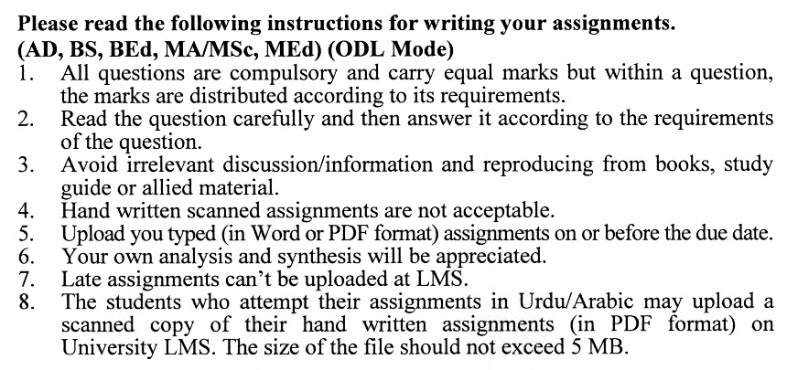

## Total Marks: 100 Pass Marks: 50

**ASSIGNMENT No. 1**

**(Units: 1–4)**

Q. 1 Mention major sources of news for radio. **(20)**

Q. 2 How did radio develop in Pakistan starting from the pre-partition era? **(20)**

Q. 3 Compare radio with television. Also, discuss the credibility of broadcasting. **(20)**

Q. 4 What are the basic principles of drafting news for radio? **(20)**

Q. 5 Create a sample radio news bulletin of 10 minutes duration following the format of Radio Pakistan. **(20)**

## Total Marks: 100 Pass Marks: 50

**ASSIGNMENT No. 2**

**(Units: 5–9)**

Q. 1 What is the role of radio in social development? Elaborate with examples. **(20)**

Q. 2 Classify different types of radio programs with suitable examples. **(20)**

Q. 3 Discuss the role of radio in enhancing education and literacy. **(20)**

Q. 4 Explain the functions of different technical equipment used in a radio station. **(20)**

Q. 5 Describe the digital satellite communication in detail. **(20)**

