**ALLAMA IQBAL OPEN UNIVERSITY, ISLAMABAD**

**(Commonwealth MBA/MPA Programme)**

**WARNING**

1. **PLAGIARISM OR HIRING OF GHOST WRITER(S) FOR SOLVING THE ASSIGNMENT(S) WILL DEBAR THE STUDENT FROM AWARD OF DEGREE/CERTIFICATE, IF FOUND AT ANY STAGE.**
2. **SUBMITTING ASSIGNMENT(S) BORROWED OR STOLEN FROM OTHER(S) AS ONE’S OWN WILL BE PENALIZED AS DEFINED IN “AIOU PLAGIARISM POLICY”.**

## Course: New Venture Planning and Launch (9556) Semester: Spring, 2025

**Level: PGD**

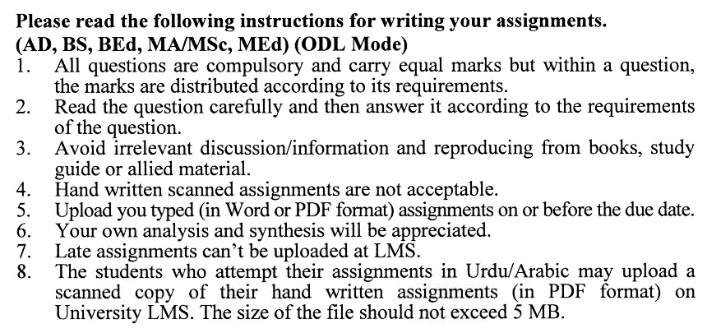

**Instructions:**

(a) All written assignment must be well organized, presented in an easy-to-read format and neat. Moreover, pay particularly close attention to grammar, spelling, punctuation and understandability. Communication is extremely important in this course.

(b) Documentation is likewise very important. Un-supported statements or opinions are worth less to the reader, who desires to verify your finding. Complete and specific documentation is mandatory. Also, your references should be to primary sources, except in rare unusual situation.

(c) Quoting should be kept to an absolute minimum.

**Guidelines for Doing Assignments**

We expect you to answer each question as per instructions in the assignment. You will find it useful to keep the following points in mind:

1) **Planning:** Read the assignments carefully, go through the Units on which they are based. Make some points regarding each question and then rearrange them in a logical order.

2) **Organization:** Be a little selective and analytical before drawing up a rough outline of your answer. Give adequate attention to question’s introduction and conclusion.

Make sure that:

a) The answer is logical and coherent,

b) It has clear connections between sentences and paragraphs,

c) The presentation is correct in your own expression and style.

3) **Presentation:** Once you are satisfied with your answer, you can write down the final version for submission. It is mandatory to write all assignments neatly. If you desire so, you may underline the points you wish to emphasize. Make sure that the answer is within the stipulated word limit.

Wish you all the best

**ASSIGNMENT No. 1**

**Total Marks: 100 Pass Marks: 50**

Q. 1 How does opportunity analysis contribute to the success of a new venture, and what are the key steps involved in this process? **(20)**

Q. 2 How can entrepreneurs adapt and evolve their business models as their ventures grow or in response to changes in the business environment and customer needs? **(20)**

Q. 3 Can you explain various revenue and profit models, including subscription-based, advertising-based, and transaction-based models, and how they align with different types of businesses? **(20)**

Q. 4 What role does data-driven decision-making play in the success of a new venture, and how can entrepreneurs collect and interpret data to support their choices and strategies? **(20)**

Q. 5 What factors determine the attractiveness of a market, and how can entrepreneurs evaluate and prioritize markets based on these factors? **(20)**

**ASSIGNMENT No. 2**

**Total Marks: 100 Pass Marks: 50**

## Instructions:

1. This assignment is a research-oriented activity. You are required to develop a term paper and submit to the tutor for evaluation prior to the final examination. The last date of this assignment will be notified separately by our directorate of regional services and the same will be communicated to you directly as well as through approved study centers assigned to you.

2. You will have to participate in the activity fully, actively, and practically to be eligible to sit in the final examination of the course.

3. For the preparation of this assignment, you should first thoroughly review the conceptual framework of the topic and develop a scholarly material of the same giving references, quotations, and extracts of various scholars and experts. Then visit any business/commercial organization and study the relevant practical aspects there. Combining the theoretical and practical aspects, develop a comprehensive paper consisting of at least 20 to 25 typed pages to be submitted to your tutor.

1. Introduction to the topic
2. Important sub-topics
3. Practical study of the organization with respect to the topic
4. Review of theoretical and practical situations, merits, de-merits deficiencies or strengths of the organization with respect to the topic under study.
5. Conclusion and recommendation
6. Annex, if any

4. Prepare a copy of this assignment and submit to your tutor for your evaluation.

5. You should add any illustrative material/data/tables/analysis for effective submission.

6. A number of topics given below are the general aspects of the course and you are required to select one of the topics according to the last digit of your roll number. For example, if the roll number is N-9337241, you will select topic number 1, and if the roll number is O-3427185 then you will select topic number 5 (the last digit).

**List of Topics:**

1. Brand Development in Venture Capitalism
2. Building a suitable team for business success
3. Competitive Advantage
4. Customer Acquisition
5. Evaluating the sources of Debt Financing
6. Launch Readiness
7. Launch Readiness for new product
8. Product Realization
9. Role of traditional Venture capital firms in Pakistan
10. Team Dynamics

**ALLAMA IQBAL OPEN UNIVERSITY ISLAMABAD**

**(Department of Business Administration)**

**Course: New Venture Planning and Launch Course Code: 9556**

**Level: PGD Credit Hours: 03**

**Unit 1: Opportunity Analysis**

1.1 New Venture Opportunity

1.2 Business Model Formation

**Unit 2: Customer Analysis**

2.1 Customer Segmentation

2.2 Customer Discovery

**Unit 3: Market Analysis**

3.1 Market Attractiveness

3.2 Industry Ecosystem

**Unit 4: Strategy and Competitor Analysis**

4.1 Competitor Assessment

4.2 Competitive Advantage

**Unit 5: Innovation**

5.1 Product Realization

5.2 Brand Development

**Unit 6: Launching Plans**

6.1 Go-to Market plans and development

6.2 Customer Acquisition

**Unit 7: Financial Planning**

7.1 Sources of Financing

7.2 Evaluating the sources

7.3 New venture funding

**Unit 8: Team Building and Developing Partnerships**

8.1 Building a suitable team

8.2 Establishing Roles

8.3 Team Dynamics

**Unit 9: Leadership**

9.1 Revenue and Profits Models

9.2 Decision making

9.3 Launch Readiness

**Recommended Textbook:**

Launching New Ventures: An Entrepreneurial Approach by Kathleen R. Alle

