ALLAMA IQBAL OPEN UNIVERSITY, ISLAMABAD

**(Department of Mass Communication)**

|  |
| --- |
| **WARNING**   1. **PLAGIARISM OR HIRING OF GHOST WRITER(S) FOR SOLVING THE ASSIGNMENT(S) WILL DEBAR THE STUDENT FROM THE AWARD OF DEGREE/CERTIFICATE IF FOUND AT ANY STAGE.** 2. **SUBMITTING ASSIGNMENT(S) BORROWED OR STOLEN FROM OTHER(S) AS ONE’S OWN WILL BE PENALIZED AS DEFINED IN THE “AIOU PLAGIARISM POLICY”.** |

**Course: Advance Theories and Strategies of Mass Communication-I / Theories of Mass Communication-I (9273/5635)**

**Level: BS / MSc Mass Communication Semester: Spring, 2025**

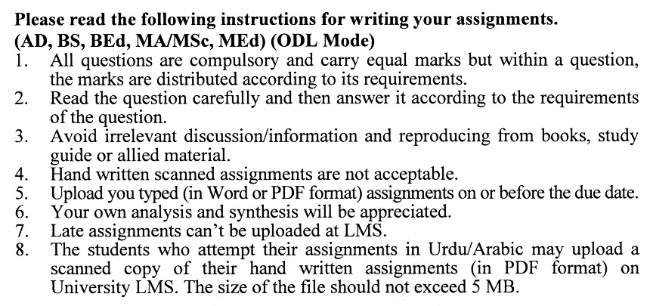

**Total Marks: 100 Pass Marks: 50**

**ASSIGNMENT No. 1**

Q. 1 Define scientific theory and explain its characteristics. Also, highlight the need of scientific theories. **(15)**

Q. 2 Define science and explain the process of a scientific inquiry. How scientific method is different from other methods/ways of knowledge? **(15)**

Q. 3 Define mass communication. What impact of the new communication technology do you see the definition and processes of mass communication in the present age? Explain why scholars feel the need for new theories of mass communication for an explanation of the media landscape of the present age. **(15)**

Q. 4 Define a model and discuss the functions and criteria of evaluation of a model. Explain the process of mass communication in both linear and circular models **(15)**

Q. 5 What are normative theories? Compare the four theories of the press. **(20)**

Q. 6 What functions mass media perform for society? Also, explain the present state of Pakistani mass media under the context of political economy theory. **(20)**

**Total Marks: 100 Pass Marks: 50**

**ASSIGNMENT No. 2**

Q. 1 What is encoding? What are the in-built characteristics of language? Why these characteristics are considered as potential roadblocks to encoding in communication? Moreover, how these potential problems in encoding can be removed? Give your own examples. **(20)**

Q. 2 Define perception. What are those factors that influence perception? Also, discuss the role of perception in mass communication behavior. **(20)**

Q. 3 Define propaganda and differentiate it from persuasion. Give a brief history of propaganda. Moreover, explain the various devices/ methods of propaganda with your own examples from the Pakistani society. **(20)**

Q. 4 Discuss the Balance theory, Newcomb’s Symmetry theory and Osgood’s Congruity Theory with examples. **(20)**

Q. 5 Explain the principles and techniques of persuasion. **(20)**

