ALLAMA IQBAL OPEN UNIVERSITY, ISLAMABAD

**(Department of Mass Communication)**

|  |
| --- |
| **WARNING**   1. **PLAGIARISM OR HIRING OF GHOST WRITER(S) FOR SOLVING THE ASSIGNMENT(S) WILL DEBAR THE STUDENT FROM THE AWARD OF DEGREE/CERTIFICATE IF FOUND AT ANY STAGE.** 2. **SUBMITTING ASSIGNMENT(S) BORROWED OR STOLEN FROM OTHER(S) AS ONE’S OWN WILL BE PENALIZED AS DEFINED IN THE “AIOU PLAGIARISM POLICY”.** |

**Course: Advance Theories and Strategies of Mass Communication-II / Theories of Mass Communication-II (9274/5636)**

**Level: BS / MSc Mass Communication Semester: Spring, 2025**

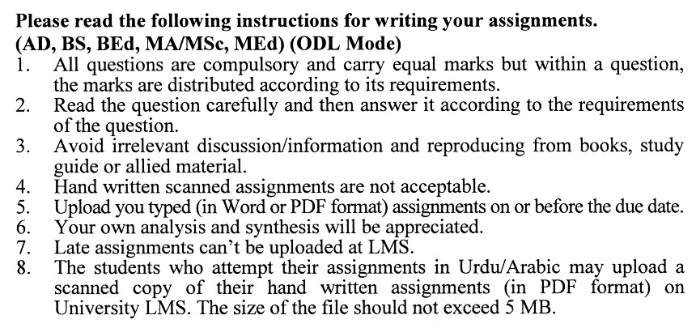

**Total Marks: 100 Pass Marks: 50**

**ASSIGNMENT No. 1**

Q. 1 What is group pressure? How does community influence an individual’s decision-making, especially the mass media-using behaviour? **(20)**

Q. 2 Explain the background and process of the two-step flow model of mass Communication. Moreover, discuss why other scholars criticized this model. **(20)**

Q. 3 What are the basic assumptions of diffusion of innovation theory? Additionally, discuss the characteristics of “innovation” and types of “adopters’ categories”. **(20)**

Q. 4 What are the basic assumptions of agenda-setting theory assume? How is this theory different from framing theory? Explain agenda-setting techniques of both print and electronic news mass media. **(20)**

Q. 5 Discuss the Knowledge Gap hypothesis with special reference to the role of mass media. **(20)**

**Total Marks: 100 Pass Marks: 50**

**ASSIGNMENT No. 2**

Q. 1 What are the basic assumptions of cultivation theory? Discuss the concepts of mainstreaming”, “resonance” and “mean world syndrome” under the context of Cultivation theory. **(20)**

Q. 2 Discuss the Magic Bullet theory. Also through light on powerful and limited effects models of mass media. **(20)**

Q. 3 Critically discuss the theory of the spiral of silence in the context of public opinion-building. **(20)**

Q. 4 Critically discuss the Magic Bullet theory. Additionally, discuss the powerful and limited effects models of mass communication. **(20)**

Q. 5 Write short notes on the following: **(20)**

i. Media Hegemony

ii. Intercultural Communication

