**ALLAMA IQBAL OPEN UNIVERSITY, ISLAMABAD**

***(Department of Economics)***

**WARNING**

1. **PLAGIARISM OR HIRING OF GHOST WRITER(S) FOR SOLVING THE ASSIGNMENT(S) WILL DEBAR THE STUDENT FROM THE AWARD OF DEGREE/CERTIFICATE IF FOUND AT ANY STAGE.**
2. **SUBMITTING ASSIGNMENT(S) BORROWED OR STOLEN FROM OTHER(S) AS ONE’S OWN WILL BE PENALIZED AS DEFINED IN THE “AIOU PLAGIARISM POLICY”.**

## **Course: Fundamentals of Econometrics (9313) Semester: Spring, 2025**

## **Level: Level: BS Economics Credit Hours: 03**

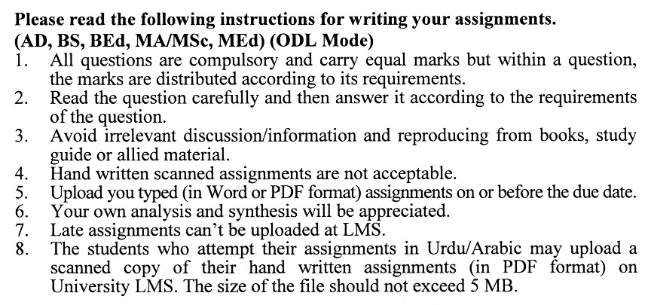

**Total Marks:100 Pass Marks:50**

**ASSIGNMENT NO. 1**

**(Unit: 1-5)**

Q.1 Differentiate among Economic and Econometric Models. (20)

Q.2 Explain the significance of stochastic disturbance terms. (20)

Q.3 Explain the variance and the testing of the Hypothesis. (20)

Q.4 What is OLS estimation? Explain. (20)

Q.5 Discuss the important tests to detect Multicollinearity. (20)

**Total Marks: 100 Pass Marks: 50**

**ASSIGNMENT NO. 2**

**(Unit: 6-9)**

Q.1 Discuss various tests of detecting Heteroscedasticity. (20)

Q.2 Explain in detail various methods of Correcting Autocorrelation. (20)

Q.3 Explain the concept of the Nested and Non-Nested Model. (20)

Q.4 Explain various Methods of identification of Simultaneous Equations. (20)

Q.5 Describe the limitations of Dynamic Analysis. (20)