**ALLAMA IQBAL OPEN UNIVERSITY, ISLAMABAD**

***(Department of Economics)***

**WARNING**

1. **PLAGIARISM OR HIRING OF GHOST WRITER(S) FOR SOLVING THE ASSIGNMENT(S) WILL DEBAR THE STUDENT FROM THE AWARD OF DEGREE/CERTIFICATE IF FOUND AT ANY STAGE.**
2. **SUBMITTING ASSIGNMENT(S) BORROWED OR STOLEN FROM OTHER(S) AS ONE’S OWN WILL BE PENALIZED AS DEFINED IN THE “AIOU PLAGIARISM POLICY”.**

**Course: Econometric Methods & Techniques (9314) Semester: Spring, 2025**

**Level: BS Economics Credit Hours:03**

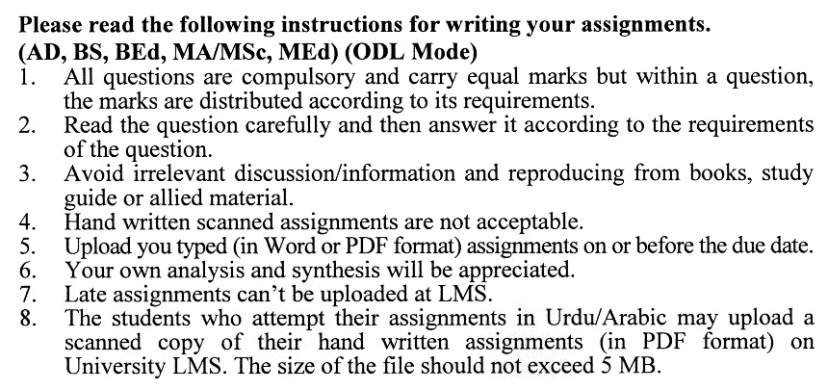

**Total Marks:100 Pass Marks:50**

**ASSIGNMENT NO. 1**

**(Unit: 1-5)**

Q.1 What are Non-Linear Econometric Models? Explain. (20)

Q.2 Explain the nature of Dummy Variables. (20)

Q.3 Analyze the concept of Qualitative Response Models. (20)

Q.4 Explain the role of time or lag in economics. (20)

Q.5 Explain the concept of Stationarity in Econometrics. (20)

**Total Marks: 100 Pass Marks: 50**

**ASSIGNMENT NO. 2**

**(Unit: 6-9)**

Q.1 What are Autoregressive Models? Explain with the help of examples. (20)

Q.2 Explain in detail the concept of the Granger Causality Test. (20)

Q.3 Explain the concept of the Nested and Non-Nested Model. (20)

Q.4 Discuss the basic concept of Co-Integration analysis. (20)

Q.5 Describe the concept of Error Correction Mechanism (ECM). (20)